**CONTRACT FOR HIRE**

THIS CONTRACT for the hiring of PETER WAINRIGHT (solo guitarist) is made this       day of      , 20     .

PETER WAINRIGHT agrees to render his abilities as Musician to the Purchaser according to the following terms and conditions.

Location of engagement:       (address)

Date of engagement:

Hours of engagement:       (starting/stopping time)

Fee agreed upon:

To be paid via       (method of payment) on:       (date)

The agreement of the Musician to perform is subject to proven detention by sickness, accidents or accidents to means of transportation, riots, epidemics, acts of God or any other legitimate conditions beyond the control of the Musician. This contract can be voided at any time with the mutual written consent of Musician and Purchaser to allow for amendments necessary to either party.

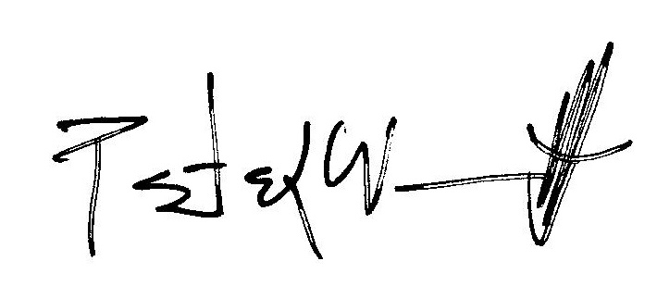

_________________________________

Purchaser’s Name (printed) Musician’s Name (printed)

_________________________________ _______________________________

Signature of Purchaser Signature of Musician

_________________________________

Street Address

_________________________________

City Province

_________________________________

Phone #

_________________________________

Email address